TAKE NOTICE that the Council of the Corporation of the United Counties of Stormont, Dundas and Glengarry has received a request to amend the Counties Official Plan to permit a site-specific exception from to the County Roads Entrance policies. The Corporation of the United Counties of Stormont, Dundas and Glengarry has determined that the application is complete in accordance with section 22 of the Planning Act, R.S.O. 1990, as amended. The application has been assigned to file number OPA No. 34.

PUBLIC MEETING
The Council of the Corporation of the United Counties of Stormont, Dundas and Glengarry (SDG) will hold a Public Meeting as per Section 17 and Section 22 of the Planning Act, R.S.O. 1990, as amended.

Date: Monday August 24th, 2026
Time: 9:00 A.M.
Location: SDG Counties Administrative Building
26 Pitt Street, Cornwall, K6J 3P2
2nd Floor, Council Chambers.

SUBJECT LANDS
This amendment applies to the lands legally described as Concession 1, S.S.R.R., Part of Lot 10, being Part 1 on Reference Plan 14R-396, known municipally as at 19291 County Road 19, Township of South Glengarry.

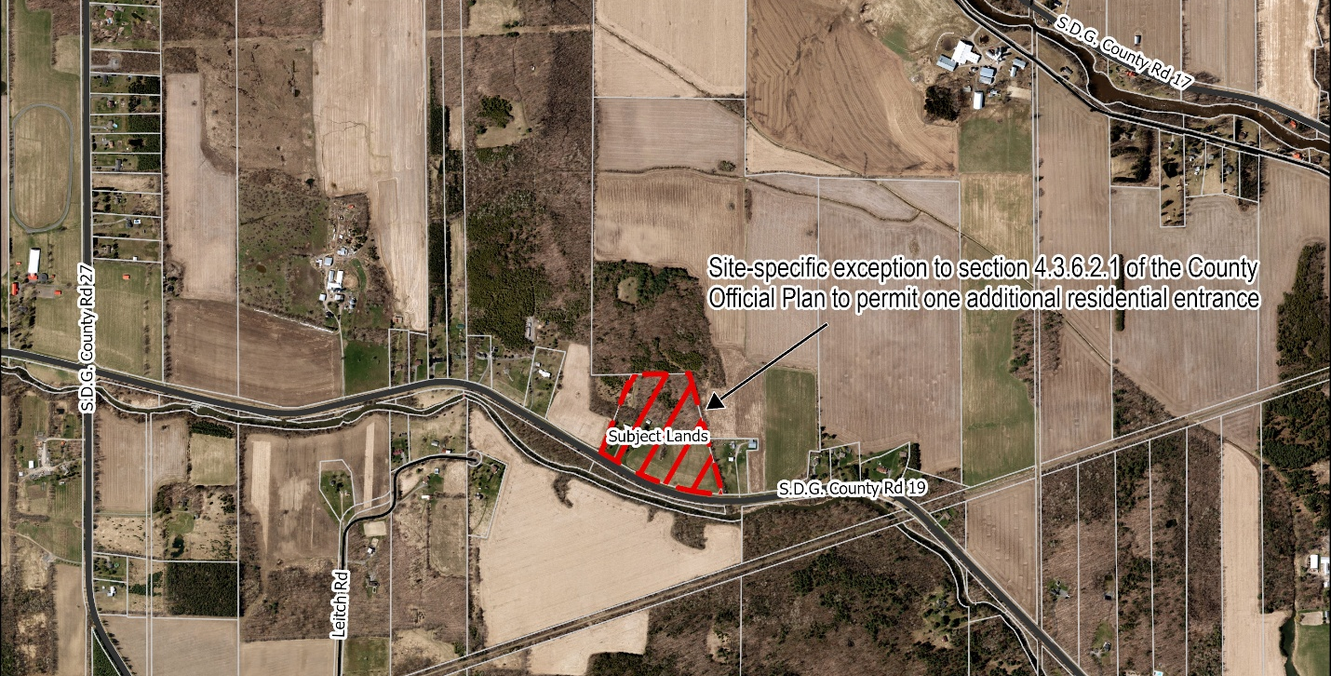

THE PURPOSE AND EFFECT of the Public Meeting is to provide the public an opportunity to give input in respect of the proposed amendment. Official Plan Amendment (OPA) No. 34 is intended to permit one additional residential entrance on the north side of County Road 19. This OPA is necessary to facilitate a future severance application to create a new rural residential lot at 19291 County Road 19.

PROPOSED COUNTY OFFICIAL PLAN AMENDMENT
The proposed amendment seeks to permit a site-specific exception from the policies of Section 4.3.6.2.1 Development Adjacent to County Roads, in the County Official Plan which limits the total number of entrances and driveway access onto a County Road. There are no proposed changes to the existing land use designation of the subject property as residential uses are permitted. No other planning applications are being considered at this time.

COMMENTS
Comments regarding the proposed Official Plan Amendment should be submitted to the United Counties of Stormont, Dundas and Glengarry’s Planning Services Department, located at 26 Pitt Street, Cornwall, Ontario K6J 3P2 or email: planning@sdgcounties.ca.

NOTE: Written comments must be received no later than September 7th, 2026. If no comments are received by that date, it will be assumed that your agency has no objection to, or comment on, the proposed application.

Any person or public body may attend the public meeting and/or make written or verbal representation either in support of, or in opposition to the proposed amendment to the Official Plan. If you would like to attend or participate, please email: planning@sdgcounties.ca in advance of the public meeting.

REQUEST FOR NOTICE OF DECISION
If you wish to be notified of the decision of the United Counties of Stormont, Dundas and Glengarry’s Council on the proposed Official Plan Amendment, you must make a written request to the Planning Services Department at the address below or email: planning@sdgcounties.ca.

APPEAL INFORMATION
If a person or public body would otherwise have an ability to appeal the decision of SDG Counties to the Ontario Land Tribunal but the person or public body does not make oral submissions at a public meeting or make written submissions to SDG Counties before the proposed official plan amendment is adopted, the person or public body is not entitled to appeal the decision.

If a person or public body does not make oral submissions at a public meeting or make written submissions to SDG Counties before the proposed official plan amendment is adopted, the person or public body may not be added as a party to the hearing of an appeal before the Ontario Land Tribunal unless, in the opinion of the Tribunal, there are reasonable grounds to add the person or public body as a party.
ADDITIONAL INFORMATION
For more information regarding the proposed Official Plan Amendment (OPA No. 34), including information about appeal rights, please contact the Planning Services Department. Additional information may also be available on the SDG Counties website.

DATED this 27th day of July 2026
Planning & Economic Development Services
SDG Counties
26 Pitt Street, K6J 3P2
Cornwall, Ontario
Tel: (613) 932-1515

